### Deleting a User Group

User groups with assigned users or child user groups may not be deleted. To delete a user group that does not have users or child user groups, select the user group and click the **Delete User Group** button.

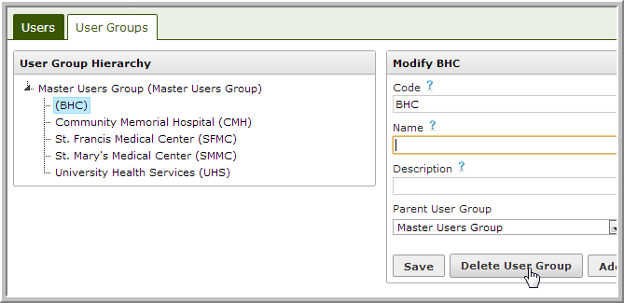

If the user group has assigned users or child user groups, the following message will appear:

